THE EFFECTIVENESS OF USING MOVIE AS AUTHENTIC MATERIAL TO IMPROVE STUDENTS’ SPEAKING ABILITY OF THE ELEVENTH GRADE STUDENTS OF GOC (GLOBAL ORIENTED CLASS) XI IPA 2 OF MAN 2 TULUNGAGUNG

THESIS

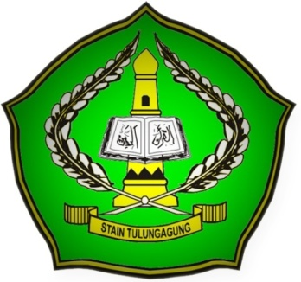

By

AMINAH IBRAHIM ABBAD
NIM. 3213083002

ENGLISH EDUCATION PROGRAM
DEPARTMENT OF ISLAMIC EDUCATION
STATE ISLAMIC COLLEGE
(STAIN) TULUNGAGUNG
2012

