BIBLIOGRAPHY

Arikunto, Suharsimi, 2006. Prosedure Penelitian Suatu Pendekatan Praktik, Jakarta: Rineka Cipta.

Ary, Donald et. 2006. Introduction to Research in Education. Canada: United State of America

Brown,H.Douglas. 2001. Teaching by principles: An Interactive Approach to Language Pedagogy. New York: Addison Wesley Longman,Inc.

Brown; J. W;Lewis R. B:Harcleroad, F. F, 1988. AV Instruction: Technology, Media, and Method. New York: Mc. Grow Hill Company.

Cahyono, Bambang. Y. 2010. The Teaching of English Language Skills and English Language Components. Malang: State University of Malang Press
Clark, eve, 2003. First Language Acquisition, Cambridge: University press.

Djuharie, Otong Setiawan.2007. Genre. Bandung: CV Yrama Widya

Gay, L.R. 1992. Educational Research Competencies for Analysis and Application Fourth Edition. New York: Mac Publishing Company.

Harmer, Jeremy. 1998. Ho to Teach English, England: Pearson Education Limited.

Harmer, Jeremy. 2007. Ho to Teach English, England: Pearson Education Limited.

Hedge,Tricia, 2000. Teaching and Learning in the Language Classroom, London: Oxford University Press.

J. B. Heaton, Longman Handbooks for Language Teacher, 1988 Writing English Language Test new edition, New York: Longman Group UK IMITED.

Jack C. Richard, 1992. Longman Dictionary of Language Teaching and Applied Linguistics second edition. England: Longman Group UK Limited.

Kuntjojo, 2009. Model-Model Pembelajaran, Kediri: Universitas Nusantara PGRI Kediri.

Mickulecky, Beatrice, 2011. A Short Course in Teaching Reading: Pearson Longman.

Nunan, David (2003). Practical English Languge Teaching: McGraw-Hill Companies
Olson, J.P. and M.H Dillner, 1982. Learning to Teach Reading in Elementary School. London: Macmillan Publishing Company.

Riduwan, 2011. Belajar Mudah Penaitian Untuk Guru-Karyawan dan Peneliti Pemula, Bandung: Alfabeta.

Setiyadi, Dwi, 1991. Linguistics the General Principles, Semarang.

Slavin, E. Robert. 1995. Cooperative Learning Theory, Research and Practice. England: John Hohn Hopkins University.

Snow, Catherine C, 2002. Reading for Understanding toward an R&D Program in Reading Comprehension: RAND.

Sugiyono, 2010. Metode Penelitian Pendidikan Kuantitatif, kualitatif dan R&D, Bandung: Alfabeta.

Appendix 1

List of students of Experimental Class (VIII^{A})

No. | Name | Male/ Female
1 | Abdul kkholiq | M
2 | Arik khusnul ma'wa | F
3 | Bayu kurniawan | M
4 | Binti nur fuadah | F
5 | Fita mahfudhoh | F
6 | Harjito | M
7 | Heni kurniawan | F
8 | Irfan Fiki Ardi | M
9 | Kamim muzaki | M
10 | M. sugeng hariadi | M
11 | M. wahyu anang | M
12 | M. zamroni | M
13 | Nilna sa'adah | F
14 | Niswatul imroatul | F
15 | Nur sida rizqiana | F
16 | Prayetno | M
17 | Purwanti | F
18 | Rifikatul afidah | F
19 | Ulil abidah | F
20 | Yudha bidhianto | M
21 | Ahmad nur fauzi | F

Appendix 2

List of students of Control Class (VIII^{c})

No. | Name | M/F
1 | Agung Fuadin | M
2 | Ali mashar | M
3 | Azzamzami M | M
4 | Binti safitri | F
5 | Denisa | F
6 | Dwi mupita sari | F
7 | Hemin sri wulan | F
8 | Imam bastomi | M
9 | Miftakhul khoiriyah | F
10 | M. faridho | M
11 | M.sulkhi widodo | M
12 | Mahfudhoh | F
13 | M. sofyan | M
14 | Rahmad deni | M
15 | Riza irsyadillah | F
16 | Siti masyithoh | F
17 | Umi kulsum | F
18 | Zeni dwi rahayu | F

Appendix 3

RENCANA PELAKSANAAN PEMBELAJARAN
( RPP )

Satuan pendidikan : MTs Sunan Ampel Ringinrejo Kediri
Mata pelajaran : Bahasa Inggris
Kelas / Semester : VIII / II
Tema : What Do You Think of the Story?
Skill : Reading
Alokasi Waktu : 2x 40 menit ( 1 x pertemuan )

- Standar Kompetensi
11. Memahami makna dalam esei pendek sederhana berbentuk narrative untuk berinteraksi dengan lingkungan sekitar.

- Kompetensi Dasar
11.1 Membaca nyaring bermakna teks fungsional dan esei pendek sederhana berbentuk narrative dengan ucapan, tekanan dan intonasi yang berterima yang berkaitan dengan lingkungan sekitar

- Indikator
- Membaca nyaring dan bermakna teks essai berbentuk narrative.
- Mengidentifikasi berbagai makna teks narrative..

- Tujuan Pembelajaran
Diakhir pembelajaran siswa mampu:
- Menjawab pertanyaan yang berkaitan dengan text narrative
- Menggunakan kata yang berbentuk verb 2 dalam menjawab pertanyaan yang berkaitan dengan text narrative
- Karakter siswa yang diharapkan:
Dapat dipercaya (Trustworthines)
Rasa hormat dan perhatian (Respect)
Tekun (Dilligence)

- Materi Pembelajaran

Narrative Text
Teks narasi adalah sebuah jenis teks yang bertujuan untuk menghibur pendengar atau pembacanya. Teks ini bertalian dengan pengalaman nyata, khayal atua peristiwa pelik yang mengarah pada krisis yang pada akhirnya menemukan suatu penyelesaian.
Ciri teks narasi adalah adanya unsur konflik (masalah) dan resolusi (penyelesaian masalah). Dalam sebuah teks naratif, kita biasa menemukan konflik dan penyelesaiannya lebih dari satu.

Struktur Teks Narative:

- Orientation : Pengenalan tokoh, waktu dan tempat.
- Complication : Pengembangan konflik (masalah)
- Resolution : Penyelesaian konflik (masalah)
- Re-orientation : Perubahan yang terjadi pada tokoh atau pelajaran yang dapat dipetik dari cerita (bagian ini bersifat operasional, tidak harus ada dalam sebuah teks)

Snow White
Once upon a time there lived a little, named Snow White. She lived with her aunt and uncle because her parents were died.
One day she heard her aunt and uncle talking about leaving Snow White in the castle because they wanted to go to America and they didn’t have enough money to take Snow White with them.
Snow White didn’t want her uncle and aunt to do this. So she decided to run away. The next morning she run away from home when her aunt and uncle were having breakfast, she run away into the wood.
In the wood she felt very tired and hungry. Then she saw this cottage. She knocked but no one answered so she went inside and felt asleep
Meanwhile seven dwarfs were coming home from work. They went inside. There, they found Snow White woke up. She saw the dwarfs. The dwarfs said; “What is your name?”. Snow White said; “My name is Snow White”. One of the dwarfs said; “If you wish, you may live here with us”. Snow White told the whole story about her. Then Snow white ad the seven dwarfs lived happily ever after

- Metode Pembelajaran
STAD (Student Team Achievement Division) technique

- Langkah-langkah Pembelajaran
Pertemuan awal :
- Kegiatan awal (10 menit)
Apersepsi:
- Guru memberi pertanyaan untuk mengkaitkan materi yang pernah dipelajari dengan yang akan dipelajari, misal:
What do you know about Snow White?
How do you know about that?
Motivasi:
- Menjelaskan pentingnya materi yang akan dipelajari berikut kompetensi yang harus dikuasai siswa.

- Kegiatan inti (60 menit)
Eksprorasi
Dalam kegiatan eksplorasi , guru:
- Membentuk kelompok yang beranggotakan 4 orang secara heterogen , campuran menurut prestasi, jenis kelamin, dll).
- Mengeksplorasi ekspresi yang tepat untuk membacakan bacaan dengan tema tersebut.
- Menggunakan beragam pendekatan pembelajaran, media pembelajaran, dan sumber belajar lain
- Memfasilitasi terjadinya interaksi antar peserta didik serta antara peserta didik dengan guru, lingkungan, dan sumber belajar lainnya
- Melibatkan peserta didik secara aktif dalam setiap kegiatan pembelajaran
Elaborasi
Dalam kegiatan elaborasi, guru:
- Membiasakan peserta didik membaca yang beragam melalui tugas-tugas tertentu yang bermakna
- Memfasilitasi peserta didik melalui diskusi untuk memunculkan gagasan baru secara tertulis.
- Memberi kesempatan untuk berfikir, menganalisa dan bertindak tanpa rasa takut.
- Mamfasilitasi peserta didik dalam pembelajaran kooperatif.
- Memfasilitasi peserta didik berkompetensi secara sehat untuk meningkatkan prestasi belajar.
- Memfasilitasi peserta didik membuat laporan eksplorasi yang dilakukan tertulis secara berkelompok.
- Memfasilitasi pesertta didik untuk menyajikan hasil kerja kelompok.
- Memfasilitasi peserta didik meakukan kegiatan yang menumbuhkan kebanggaan dan rasa percaya diri peserta didik.
Konfirmasi
Dalam kegiatan konfirmasi, guru:
- Memberikan umpan balik positif dan penguatan dalam bentuk lisan dan hadiah terhadap keberhasilan peserta didik.
- Memberikan konfirmasi terhadap hasil eksplorasi dan elaborasi peserta didik melalui berbagai sumber.
- Memfasilitasi peserta didik melakukan refleksi untuk mempeeroleh pengalaman belajar yang telah dilakukan.
- Bertanya jawab tentang kosa kata yang belum diketahui siswa.
- Guru bersama siswa bertanya jawab meluruskan kesalahan pemahaman, memberikan penguatan dan penyimpulan.

- Kegiatan penutup (10 menit)
Dalam kegiatan penutup, guru:
- Menanyakan kesulitan peserta didik dalam memahami teks narative.
- Bersama-sama peserta didik menyimpulkan materi
- Melakukan penilaian terhadap kegitan yang sudah dilaksanakan secaa konsisten dan terprogram.
- Memberikan umpan balik terhadap proses dan hasil pembelajaran.
- Menyampaikan rencana pembelajaran pada petemuan berikutnya.
- Guru menutup pelajaran

- Sumber Belajar
- “Passport to the World 2 a Fun and Easy English Book for Grade VIII of Junior High Schools” page 134.
- Kamus Indonesia-inggris dan inggris-indonesia
- Buku lain yang berkaitan dengan materi

- Penilaian
- Teknik : tes tulis
- Bentuk : subyektif tes
- Instrumen :
Read the text below. Then answer these questions correctly!
The Lion and the Mouse
Once, as a lion was asleep in his den, a naughty little mouse ran up his tail. He then run onto his back and up his mane and jumped on his head. This soon wakened the Lion.
The lion grabbed the mouse and held him in his large claws, roared in anger.
‘How dare you wake me up! Don’t you know that I am king of Beast? Anyone who disturbs my rest deserves to die! I shall kill you and eat you!’ The mouse was terrified. He begged the lion to let him go.
‘Please don’t eat me your Majesty! I did not mean to wake you, it was mistake. I was only playing. Please let me go – I promise I will be your friend forever. Who knows but one day I could save your life?’
‘This lion looked at the tiny mouse and laughed. ‘You save my life? What an absurd idea!’ he said scornfully. ‘But you have made me laugh, and put me into a good mood again, so I shall let you go.’ And the lion opened his claws and let the mouse go free.
‘Thank you your Majesty’, squeaked the mouse, then he run away as fast as he could.
A few days later, the lion was caught in a hunter’s snare. He tried to struggle, but he couldn’t break free and become even more entangled in the net of ropes. He let out a roar of anger that shook the forest. Every animal heard it, including the tiny mouse.
‘My friend the lion is in trouble,’ cried the mouse. He ran as fast as he could in the direction of the lion’s roar. Soon he found the lion trapped in the hunter’s snare.
‘Hold still, your majesty,’ squeaked the mouse. ‘I’ll have you out of there in a jiffy! And without further delay, the mouse began nibbling through the ropes with his sharp little teeth. Very soon the lion was free.
‘I did not believe that you could help me, little mouse. But today you saved my life,’ said the lion humbly.
‘It was my turn to help you, your Majesty.’ answered the mouse.
Taken from Passport to the World 2 a Fun and Easy English Book for Grade VIII of Junior High School, published by Tiga Serangkai Pustaka Mandiri.

Answer these Questions Correctly Base on Narrative text above!
- What kind of text was it?
- What did the lion do in his den?
- Where was the lion asleep?
- What did the mouse do in the lion’s den?
- What happened to the lion after the mouse jump to the lion’s head?
- What happened to the mouse?
- What happened to the lion few days after he met the mouse?
- Why couldn’t the lion free him self?
- Who was caught the lion?
- How did the mouse free the lion?

Key answers:

- Narrative text
- The Lion was asleep.
- The lion asleep in his den.
- The mouse ran up his tail. He then run onto his back and up his mane and jumped on his head.
- The lion grabbed the mouse and held him in his large claws, roared in anger.
- The mouse was terrified.
- The lion was caught in a hunter’s snare.
- Because the lion entangled in the net of ropes.
- The hunter was caught the lion.
- The mouse nibbling through the ropes with his sharp little teeth.

Rubrik Penilaian :
No | Uraian | Skor
1 s.d. 10 | - Setiap jawaban benar, struktur kalimat dan ejaan benar.  - Setiap jawaban benar, struktur kalimat benar, ejaan kurang tepat.  - Setiap jawaban benar, struktur kalimat dan ejaan kurang tepat.  - Setiap jawaban kurang tepat, struktur kalimat salah, ejaan salah.  - Setiap jawaban salah, struktur kalimat dan ejaan salah.  - Tidak ada jawaban. | 5  4  3  2  1  0

Pedoman penilaian:
- No 1 sampai 10 jawaban benar skor : 5
- Skor max 10x5 :50
- Nilai max :100
- nilai siswa =

Guru Pamong  Dra. Ma’unah M.Pd  NIP. | Kediri, 18 Mei 2012  Praktikan  Ida laelatul hidayah  NIM. 3213083065

Appendix 4

The Students’ reading achievement of experimental Group
No. | Subject | Question |  |  |  |  |  |  |  |  |  |  |  | Total | Score
 |  | 1 | 2 | 3 | 4 | 5 |  | 6 | 7 |  | 8 | 9 | 10
1 | AK | 0 | 5 | 5 | 5 | 0 |  | 5 | 5 |  | 5 | 4 | 5 | 39 | 78
2 | AKM | 5 | 4 | 4 | 4 | 5 |  | 5 | 5 |  | 2 | 4 | 4 | 42 | 84
3 | BK | 5 | 4 | 5 | 5 | 5 |  | 1 | 4 |  | 0 | 5 | 5 | 39 | 78
4 | BNF | 5 | 5 | 5 | 5 | 4 |  | 1 | 1 |  | 5 | 5 | 1 | 37 | 74
5 | FM | 4 | 5 | 5 | 5 | 5 |  | 5 | 5 |  | 5 | 3 | 5 | 47 | 94
6 | H | 5 | 4 | 5 | 5 | 5 |  | 1 | 5 |  | 0 | 5 | 1 | 36 | 72
7 | HK | 5 | 4 | 4 | 4 | 5 |  | 1 | 5 |  | 5 | 5 | 0 | 38 | 76
8 | IF | 5 | 4 | 5 | 4 | 5 |  | 5 | 5 |  | 5 | 4 | 5 | 47 | 94
9 | KM | 4 | 5 | 4 | 4 | 5 |  | 4 | 5 |  | 4 | 4 | 4 | 43 | 86
10 | MSH | 4 | 5 | 4 | 4 | 5 |  | 4 | 5 |  | 4 | 5 | 5 | 45 | 90
11 | MWA | 5 | 4 | 5 | 5 | 5 |  | 1 | 5 |  | 1 | 5 | 0 | 36 | 72
12 | MZ | 5 | 5 | 5 | 5 | 5 |  | 1 | 5 |  | 0 | 5 | 0 | 36 | 72
13 | NS | 4 | 5 | 5 | 3 | 4 |  | 5 | 5 |  | 5 | 5 | 4 | 45 | 90
14 | NI | 4 | 4 | 5 | 4 |  | 4 | 4 |  | 5 | 5 | 3 | 4 | 42 | 84
15 | NSR | 5 | 5 | 5 | 5 |  | 5 | 5 |  | 5 | 5 | 4 | 4 | 48 | 96
16 | PR | 5 | 4 | 5 | 5 |  | 5 | 5 |  | 5 | 5 | 4 | 5 | 48 | 96
17 | PU | 5 | 5 | 5 | 4 |  | 4 | 1 |  | 2 | 5 | 5 | 1 | 37 | 74
18 | RA | 5 | 5 | 5 | 5 |  | 5 | 5 |  | 5 | 5 | 4 | 5 | 49 | 98
19 | UA | 5 | 4 | 5 | 5 |  | 5 | 5 |  | 5 | 5 | 3 | 5 | 47 | 94
20 | YB | 5 | 4 | 4 | 5 |  | 4 | 5 |  | 5 | 4 | 4 | 4 | 44 | 88
21 | ANT | 1 | 5 | 5 | 4 |  | 5 | 5 |  | 2 | 3 | 5 | 2 | 37 | 74

Appendix 5

The Students’ Reading Achievement of Control Group
No. | Subject | Question |  |  |  |  |  |  |  |  |  | Total | Score
 |  | 1 | 2 | 3 | 4 | 5 | 6 | 7 | 8 | 9 | 10
1 | AF | 1 | 5 | 5 | 5 | 4 | 1 | 4 | 2 | 1 | 1 | 29 | 58
2 | AM | 4 | 4 | 5 | 3 | 5 | 1 | 5 | 4 | 4 | 1 | 36 | 72
3 | AzM | 1 | 5 | 5 | 4 | 1 | 1 | 4 | 3 | 1 | 5 | 30 | 58
4 | BS | 5 | 0 | 5 | 5 | 5 | 1 | 5 | 3 | 4 | 4 | 37 | 74
5 | D | 5 | 4 | 3 | 5 | 1 | 1 | 5 | 4 | 2 | 4 | 34 | 68
6 | DMS | 5 | 4 | 5 | 4 | 1 | 1 | 5 | 4 | 4 | 4 | 37 | 74
7 | HSW | 5 | 5 | 0 | 4 | 5 | 1 | 4 | 3 | 4 | 4 | 35 | 70
8 | IB | 5 | 5 | 5 | 4 | 5 | 5 | 5 | 5 | 4 | 0 | 43 | 86
9 | MK | 5 | 2 | 5 | 5 | 0 | 1 | 5 | 5 | 2 | 5 | 35 | 70
10 | MF | 5 | 5 | 5 | 5 | 5 | 5 | 5 | 4 | 4 | 1 | 44 | 98
11 | MSW | 5 | 4 | 5 | 5 | 5 | 5 | 5 | 3 | 5 | 5 | 47 | 94
12 | M | 5 | 5 | 5 | 4 | 1 | 1 | 5 | 3 | 3 | 4 | 36 | 72
13 | MS | 5 | 4 | 5 | 5 | 5 | 1 | 5 | 3 | 4 | 1 | 38 | 76
14 | RD | 4 | 4 | 5 | 4 | 5 | 1 | 5 | 3 | 4 | 1 | 36 | 68
15 | RI | 4 | 3 | 4 | 5 | 5 | 4 | 4 | 4 | 2 | 4 | 39 | 78
16 | SM | 2 | 5 | 4 | 3 | 3 | 1 | 3 | 4 | 5 | 4 | 34 | 72
17 | UK | 5 | 5 | 5 | 3 | 4 | 1 | 5 | 4 | 5 | 4 | 41 | 82
18 | ZDR | 5 | 5 | 5 | 3 | 1 | 1 | 5 | 4 | 5 | 4 | 38 | 76

Appendix 6
Instrument of Test

Read the text below. Then answer these questions correctly!
The Lion and the Mouse
Once, as a lion was asleep in his den, a naughty little mouse ran up his tail. He then run onto his back and up his mane and jumped on his head. This soon wakened the Lion.
The lion grabbed the mouse and held him in his large claws, roared in anger.
‘How dare you wake me up! Don’t you know that I am king of Beast? Anyone who disturbs my rest deserves to die! I shall kill you and eat you!’ The mouse was terrified. He begged the lion to let him go.
‘Please don’t eat me your Majesty! I did not mean to wake you, it was mistake. I was only playing. Please let me go – I promise I will be your friend forever. Who knows but one day I could save your life?’
‘This lion looked at the tiny mouse and laughed. ‘You save my life? What an absurd idea!’ he said scornfully. ‘But you have made me laugh, and put me into a good mood again, so I shall let you go.’ And the lion opened his claws and let the mouse go free.
‘Thank you your Majesty’, squeaked the mouse, then he run away as fast as he could.
A few days later, the lion was caught in a hunter’s snare. He tried to struggle, but he couldn’t break free and become even more entangled in the net of ropes. He let out a roar of anger that shook the forest. Every animal heard it, including the tiny mouse.
‘My friend the lion is in trouble,’ cried the mouse. He ran as fast as he could in the direction of the lion’s roar. Soon he found the lion trapped in the hunter’s snare.
‘Hold still, your majesty,’ squeaked the mouse. ‘I’ll have you out of there in a jiffy! And without further delay, the mouse began nibbling through the ropes with his sharp little teeth. Very soon the lion was free.
‘I did not believe that you could help me, little mouse. But today you saved my life,’ said the lion humbly.
‘It was my turn to help you, your Majesty.’ answered the mouse.
Taken from Passport to the World 2 a Fun and Easy English Book for Grade VIII of Junior High School, published by Tiga Serangkai Pustaka Mandiri.

Answer these Questions Correctly Base on Narrative text above!
- What kind of text was it?
- What did the lion do in his den?
- Where was the lion asleep?
- What did the mouse do in the lion’s den?
- What happened to the lion after the mouse jump to the lion’s head?
- What happened to the mouse?
- What happened to the lion few days after he met the mouse?
- Why couldn’t the lion free him self?
- Who was caught the lion?
- How did the mouse free the lion?

Appendix 7
Instrument of Test Key Answer

Key answers:

- Narrative text
- The Lion was asleep.
- The lion asleep in his den.
- The mouse ran up his tail. He then run onto his back and up his mane and jumped on his head.
- The lion grabbed the mouse and held him in his large claws, roared in anger.
- The mouse was terrified.
- The lion was caught in a hunter’s snare.
- Because the lion entangled in the net of ropes.
- The hunter was caught the lion.
- The mouse nibbling through the ropes with his sharp little teeth.

Appendix 11
Documentations

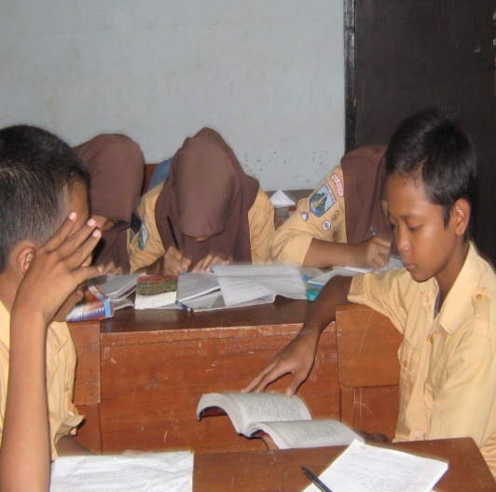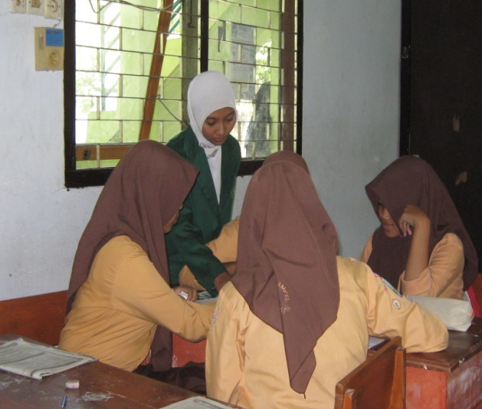

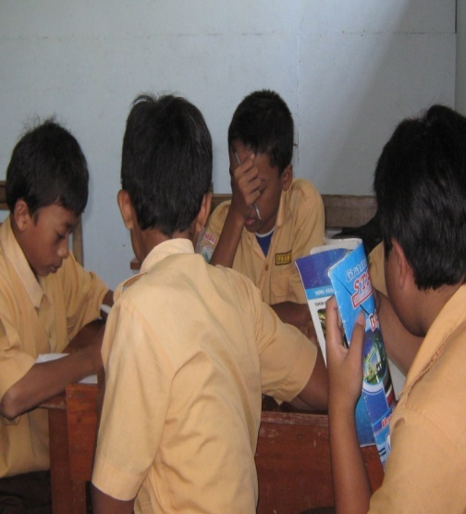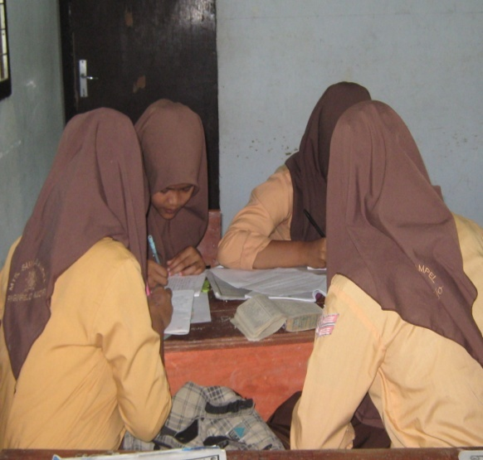

DECLARATION OF AUTHORSHIP
Name : Ida Laelatul Hidayah
Place, Date of Birth : Kediri, January 17th 1990
NIM : 3213083065
Department : English Education Program of STAIN Tulungagung
Semester : VIII
State that the Thesis entitled of “Effectiveness of Using (Student Team Achievement Division) STAD Technique on The Reading Comprehension Achievement of The Second Year Student at MTs Sunan Ampel Ringinrejo Kediri in The Academic Year 2011/2012” is truly my original work and helped by the expert of this matter. It is written and published as the requirement for the degree of Sarjana Pendidikan Islam in English Education Program, Department of Islamic Education, State Islamic College of Tulungagung in 2011/2012 Academic Year. Due the fact, I am responsible for the thesis, if there is any objection or claim from other.
Tulungagung, August 23th 2012
The Writer

Ida Laelatul Hidayah
NIM. 3213083065
CURRICULUM VITAE

Name : Ida Laelatul Hidayah
Place,date of birth : Kediri, January 17th 1990
Registered numbe : 3213083065
Address : Deyeng, Ringinrejo, Kediri
Department : Tarbiyah
Program : Tadris Bahasa Inggris
Background of the study :
- TK Darma Wanita ( 1995 – 1996 )
- SDN Deyeng II ( 1996 – 2002 )
- MTsN Kunir ( 2002 – 2005 )
- MAN Blitar ( 2005 – 2008 )
- STAIN Tulungagung ( 2008 - 2012 )

