CHAPTER IV
DATA PRESENTATION AND RESEARCH FINDINGS

In this chapter the researcher focuses on presenting the basic of the data analysis. Three main topics are discussed here. They are data presentation, and, hypothesis testing and discussion.

- Data Presentation
In this research, the researcher wants to know the different result between the students who are taught by using STAD technique and students who are not taught by using STAD technique.
- Data Presentation of Experimental group
This post test in experimental group was given by asking students to answer the questions about narrative text. The number of question was given by researcher about 10 questions. There were 21 students as respondent or subject. It was done after treatment process by giving STAD technique in the teaching and learning process. This test was intended to know the students reading achievement after students got treatment. The data of the student’s achievement of experimental group can be seen in appendix 4.

Table 4.1 Descriptive Statistic of Experimental Group
 |  | experimental_group
N | Valid | 21
 | Missing | 0
Mean |  | 84.00
Median |  | 84.00
Mode |  | 72ª
- Multiple modes exist. The smallest value is shown

Table 4.2 Frequency of experimental group

 |  | Frequency | Percent | Valid Percent | Cumulative Percent
Valid | 72 | 3 | 14.3 | 14.3 | 14.3
 | 74 | 3 | 14.3 | 14.3 | 28.6
 | 76 | 1 | 4.8 | 4.8 | 33.3
 | 78 | 2 | 9.5 | 9.5 | 42.9
 | 84 | 2 | 9.5 | 9.5 | 52.4
 | 86 | 1 | 4.8 | 4.8 | 57.1
 | 88 | 1 | 4.8 | 4.8 | 61.9
 | 90 | 2 | 9.5 | 9.5 | 71.4
 | 94 | 3 | 14.3 | 14.3 | 85.7
 | 96 | 2 | 9.5 | 9.5 | 95.2
 | 98 | 1 | 4.8 | 4.8 | 100.0
 | Total | 21 | 100.0 | 100.0

Table 4.3 Frequency Distribution of experimental group
 |  | Frequency | Percent | Valid Percent | Cumulative Percent
Valid | 71-80 | 9 | 42.9 | 42.9 | 42.9
 | 81-90 | 6 | 28.6 | 28.6 | 71.4
 | 91-100 | 6 | 28.6 | 28.6 | 100.0
 | Total | 21 | 100.0 | 100.0

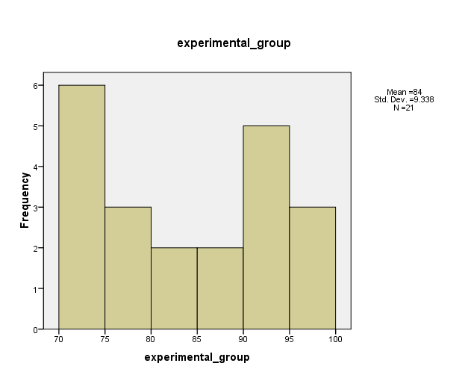

Based on the tables and histogram of experimental group above, that consists of 21 students. It shows that the mean score is 84.00, it’s mean that the average of 21 students are get score 84. The median score is 84.00, there is an equal score above and below the median. In the data score (score 72- score 98) median is 84 there are ten data scores greater than this value and ten data scores less than this value. In this case, the median is equal to the mean. The mode score is 72.00 (Multiple modes exist but smallest value is shown 72.00). In this case there are 3 modes score (72, 74 and 94) it’s mean that the most frequent score are 72, 74, and 94. The frequency of experimental group after distributed there are 9 students (42.9%) getting score between 71-80, 6 students (28.6%) getting score between 81-90, and 6 students (28.6%) getting score between 91-100.
- Data Presentation of Control group
The post test in control group was given by asking students to answer the questions about narrative text. The number of question was given by researcher about 10 questions. There were 18 students as respondent or subject. It was done after treatment process by giving traditional method in the teaching and learning process. This test was intended to know the students reading achievement after students got treatment process by giving traditional method. This test was intended to know the students reading achievement taught without using STAD technique. The data of the student’s achievement of control group can be seen in appendix 5.
Table 4.4 Descriptive Statistic of Control Group

 |  | Control Group
N | Valid | 18
 | Missing | 0
Mean |  | 74.78
Median |  | 73.00
Mode |  | 72

Table 4.5 Frequency of Control Group
 |  | Frequency | Percent | Valid Percent | Cumulative Percent
Valid | 58 | 2 | 11.1 | 11.1 | 11.1
 | 68 | 2 | 11.1 | 11.1 | 22.2
 | 70 | 2 | 11.1 | 11.1 | 33.3
 | 72 | 3 | 16.7 | 16.7 | 50.0
 | 74 | 2 | 11.1 | 11.1 | 61.1
 | 76 | 2 | 11.1 | 11.1 | 72.2
 | 78 | 1 | 5.6 | 5.6 | 77.8
 | 82 | 1 | 5.6 | 5.6  Continued ……….. | 83.3
……..Continuation table 4.5
 |  | Frequency | Percent | Valid Percent | Cumulative Percent
Valid | 86 | 1 | 5.6 | 5.6 | 88.9
 | 94 | 1 | 5.6 | 5.6 | 94.4
 | 98 | 1 | 5.6 | 5.6 | 100.0
 | Total | 18 | 100.0 | 100.0

Table 4.6 Frequency Distribution of control group
 |  | Frequency | Percent | Valid Percent | Cumulative Percent
Valid | 51-60 | 2 | 11.1 | 11.1 | 11.1
 | 61-70 | 4 | 22.2 | 22.2 | 33.3
 | 71-80 | 8 | 44.4 | 44.4 | 77.8
 | 81-90 | 2 | 11.1 | 11.1 | 88.9
 | 91-100 | 2 | 11.1 | 11.1 | 100.0
 | Total | 18 | 100.0 | 100.0

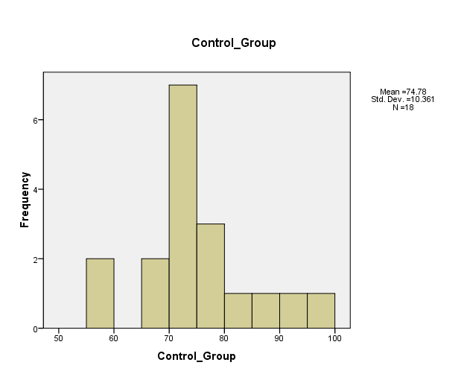

Based on the tables and histogram of control group above, that consists of 18 students. It shows that the mean score is 74.78, its mean that the averages of 18 students are get score 74. The median score is 73.00, there is an equal score above and below the median. In the data score (score 58- score 98) median is 73 there are eight data scores greater than this value and eight data scores less than this value. In this case, the median is equal to the mean and the mode score is 72.00 it’s mean that the most frequent score is 72. The frequency of control group after distributed there are 2 students (11.1%) getting score between 51-60, 4 students (22.2%)getting score between 61-70, 8 students (44.4%) getting score between 71-80, 2 students (11.1%) getting score between 81-90, and 2 students (11.1%) getting score between 91-100.
- Hypothesis Testing
The hypotheses testing of this study are as follow:
- If the significant level is bigger than T-table (0,05%), the alternative hypothesis (ha) is accepted and null hypothesis (ho) is rejected. It means that there is different score to the students who was not taught using STAD technique and the students who was taught using STAD technique. The difference is significant.
- If the significant level is smaller than T-table (0,05%), the Null Hypothesis (Ho) is accepted and the alternative hypothesis (Ha) is rejected. It means that there is not different score to the students who was taught without using STAD technique and the students who was taught using STAD technique. The difference is not significant.
To know whether the significant level is bigger or smaller than T-table, the researcher analyzed the data by using SPSS 16 0.

Table 4.7. The result of analyzing Independent Samples T Test
 |  | Levene's Test for Equality of Variances |  | t-test for Equality of Means
 |  |  |  |  |  |  |  |  | 95% Confidence Interval of the Difference
 |  | F | Sig. | t | df | Sig. (2-tailed) | Mean Difference | Std. Error Difference | Lower | Upper
Score | Equal variances assumed | .061 | .806 | 2.862 | 36 | .007 | 9.294 | 3.248 | 2.707 | 15.881
 | Equal variances not assumed |  |  | 2.821 | 32.105 | .008 | 9.294 | 3.295 | 2.583 | 16.005

Table 4.7 is t-test analysis that is used by the researcher and the result of significant level is 0,07%. By comparing significant level 0,07% and t table at 0.05%. It is known that significant level is bigger than t table = 0,07% > 0.05%. This means that Ha which states that there is significant effect of using STAD as a technique of teaching reading narrative text toward students’ reading achievement of the second year students of MTs Sunan Ampel Ringinrejo Kediri is accepted. Whereas Ho which states that There is no significant effect of using STAD as a technique of teaching reading narrative text toward students’ reading achievement of the second year students of MTs Sunan Ampel Ringinrejo Kediri is rejected.
- Discussion
Based on the data analysis, the researcher know that significant level is bigger than t table at 0,05% , the alternative hypothesis (Ha) is accepted and the null hypothesis (Ho) is rejected, it means that there is significant different reading achievement of second year students of MTs Sunan Ampel Ringinrejo Kediri between students taught by using STAD technique and students who are taught without using STAD technique.
Based on research method in chapter III in this research, the teaching and learning process was divided into four steps. First step is giving treatment for VIIIC students as control group. Treatment here is the in form of giving traditional method in the teaching and learning process. The second step is giving post test for the control group to know students achievement in reading comprehension in narrative text after they gave traditional method in the teaching and learning process. The mean’s score of this group is 74.78.
The third step is giving treatment for the VIIIA students as experimental group. Treatment here is the in form of giving STAD technique in the teaching and learning process. The fourth step is giving post test for the experimental group to know the students achievement in reading comprehension in narrative text after they gave the treatment in the form of STAD technique. The mean’s score of this group is 84.00.
Based on research finding, it showed that the mean scores seem significant different between control group that using traditional method and experimental group that using STAD technique. The mean score of control group is lower than the mean score of experimental group. Therefore, group that taught using STAD technique has higher score.
According Slavin (2005:12) the main idea of STAD is motivating the students to help and support each other in mastering the material that taught by the teacher. It means that the process of teaching learning using STAD technique, the students do not only learn from the teacher but they also can learn from each other.
After the researcher did the research in teaching reading comprehension of the second year student at MTs Sunan Ampel , the theory of Slavin above has developed. STAD technique not only motivate the students to learning reading comprehension by help and support each other in mastering the material that taught by teacher but also by those, they can work together to solve the problem that they could not solve by alone. So, they can learn to develop their ability to socialize.
In this research STAD technique is effective in teaching reading comprehension. It can be evidenced by previous studies that written by the student of STAIN Tulungagung, entitle “The effectiveness of Using Student Teams Achievement Divisions (STAD) Method to Improve Reading Comprehension Achievement of Second Year Students At Aswaja Tunggangri Tulunggung” by Adibatut Diniyah (2011). Her research showed effective in teaching learning process especially in reading comprehension.
STAD technique also appropriate in the research that used CAR (Classroom Action Research) CAR. It is proved based on the theses that has been written by Dedi Sigit, entitle “Improving Reading Comprehension by Student Team Achievement Division (STAD) Technique for Second Year Student of MTs Ma’arif NU Blitar”. In his research also showed the effectiveness to improve reading comprehension achievement by using STAD technique.
Based on the explanation above, STAD technique surely showed the real effectiveness in teaching reading comprehension because it can help the student to improve their reading comprehension achievement of the second year students of MTs Sunan Ampel Ringinrejo Kediri.

