THE EFFECTIVENESS OF TEACHING VOCABULARY BY USING CARTOON FILM TOWARD VOCABULARY MASTERY OF FOURTH GRADE STUDENTS
OF MI AL HIDAYAH 02 BETAK
ACADEMIC YEAR 2011/2012.

THESIS

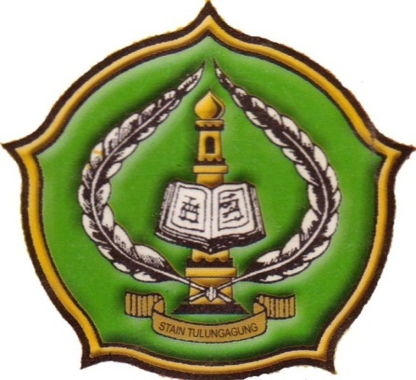

By:
FATHUL MUNIR
NIM. 3213083057

ENGLISH EDUCATION PROGRAM
DEPARTMENT OF ISLAMIC EDUCATION
STATE ISLAMIC COLLEGE (STAIN)
TULUNGAGUNG
2012

