LESSON PLAN

Education Unit : SMP 2 Sumbergempol
Subject : English
Class/semester : VII / 2
Time allocation : 3 x 40 minutes
Aspect of Skill : Listening
Standard competency
- Understanding the meaning in transactional and interpersonal conversation is very simple to interact with the immediate environment.
- Understanding the functional meaning in a short spoken text is very simpleto interact with environment.
Basic competence
11. responding to the meaning of the conversation trancsactional ( to get things Done) and interpersonal (social) which uses a very simple range of spoken language accurately, fluently, and thankful to interact with the immediate environment that involves speech act greet people said that yet/ already knew, inroduce yourself / others, and rule/ banning.
12. express the meaning of ideas in a short spoken text is very simple fuctional accurately, smoothly, and thankful to interact with the environment nearby.
Indicator
- Identify the information/meaning contained in the text/image.
- Identify the function of rhetoric text step text.

- Learning objectives
In the end of the lesson, students can :
- Acquire vocabulary assosiated with the coversation
- Obtaining a variety of information related to the type of text
- Identifying “ Thing around Us” in everyday life
- Uderstand the“ Thing around Us” in everyday life
- Apply the “ Thing arund Us” within a day - day
- Make a conclusion about the “Thing around Us”
- Learning material
Where is the book?
My book is here

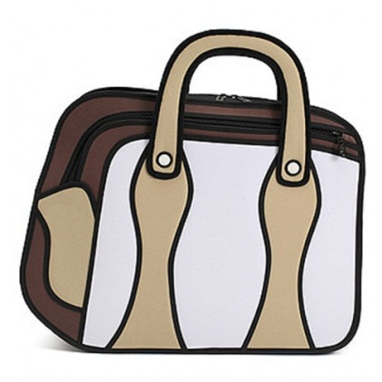

My book is in my bag

- Write out the vocabulary around us in class! Check to other groups
- Listen to your teacher and repeat!
- What is this?this is a desk
- What is that? That is a blackboard
- What’s these? These are my pens
- Is this a pen? Yes, they are
- A re these your books? Yes, they are
- Are those tables? No. They are not
- In pairs, practice in front of the class!
Example for number 1:
X : what is that?
Y : that is a book
X : are these book?
Y : No, they are not.
- Book 11) Wall
- Ruler 12) Television
- Shoe 13) Grass
- Tree 14) flag
- Helmet 15) school yards
- Parking areas 16) Ball
- Floor 17) magazine
- Mosque 18) rubbish
- Laboratory 19) butter fly
- flowers 20) stairs
- Learning methods
- The presentation, practice, product (PPP)
- Steps of activities (cycle 2):
1. | A. Pre teaching  - apperception / greeting  - absence and Completion journal  - checking students, classes, and the environment | 5 minutes
2. | B. Main teaching  - The teacher divides the student into 5 groups  - Teachers provide materials/ teaching materials  - Students observe the environment outside the classroom  - Student seeking vocabulary based on materials  - Student make conclusions with the group  - The findings in discussing  - Summing up the results | 60 minutes
3. | C. Post teaching  - Asking difficult during teaching learning  - Conclude the material  - Assesment  - Test vocabulary | 5 minutes

- Learning resources :
- LKS B. Inggris “SMP & TELENTA “ SMP Kls VII, p. 51-56 & 30
- Vocabulary test book
- English indonesia dictionary, john M echol&hasanshadaly PT Gramedia. Jkt
- Assesment
- Written tests
- Student activity within the PBM
- Instrument
- Fill the blank with appropriate words!
- We cut our hair by …………
- My sister fries the chicken on ………..
- Do not forget to close ………… pease you leave home.
- Rachael is writing a letter on ………….
- “ look at that …………… on the wall. It’s so beautiful”.
- Rudi and andi are sweeping the floor by ……………
- I clean the chair, the table and everything in my house by……….
- “lets find …………. Is not fit to my foot. It is too small. What about that one.
- This …………..is not fit to my foot. It is too small. What about that one.
- Turn off the ………… if you leave out from your room.

- Match these words with the appropiate one
- Bookcase dresser
- Pond fence
- Wardrobe security
- Fountain pencil box
- Garden box
- Fence fountain
- Security garden
- Vase pool
- Sandpit swing
- The hole swings sand

- Choose the best word by crossing a, b, c, d!
1. The three ….. are very clever.
a. a students c. Student
b. a student d. Students
2. Thera are many ….. in the class.
a. Student c. Student
b. a student d. Some student
3. Deyana ….. a short hair.
a. Does c. Has
b. Have d. Do
4. It has ….. a song.
a. large c. Thick
b. Fat d. Beautiful
5. Its ….. teeth makes his smile nice.
a. Many c. White
b. Fat d. Little
6. You have …….well tiara anggraini
a.Work c.Worked
b.Works d. Working
7. The film has …….stoped
a. Already c. Will
b. Do d. Always
8. Ginanda afifah has ……..me yesterday
a.Talk c. Told
b.Talking d. Talks
9. One night, it ………. Raining very hard
a. Is c. Was
b. Where d. Am
10. Krisma Mayang was sleeping when Romando Gentana ……..his book
a. Stelling c. stole
b. Steals d To steal

- Rubric Assessment
NO | Description | Score
I | Each correct answer  Every wrong answer | 1  0
II | Fill is true, correct grammar  Fill correct, incorect grammar  Lack of the content and grammar  No answer | 3  2  1  0

- Guide Scoring
- For the number 1, correct answer score 1
- For the number II, correct answer score 2
- The number of maximum score I 5 x 1 = 5
II 5 x 3 = 15
Total = 20

- Final score = Mean Score___ x 10
Score Maximum

Tulungagung, 20 Juli, 2014

Teacher English Teacher

Rita Yusdiana, S.Pd Agus Fahim
NIP. 19720712 200801 2 017 NIM.3213103035

