LESSON PLAN
Education Unit : SMP 2 Sumbergempol
Subject : English
Class/semester : VII/2
Time allocation : 3 x 40 minutes
Aspect of Skill : Listening
Standard competency
4. express the fuchtional meaning in ashort spoken text is very simple to interect with the immediate environment.
Basic competence
4.1 expressing the meaning of speech acts in a short spoken text is very simple fuctionalaccuratly, smoothly, and thankful to interact with the environment nearby.
Indicator
- Identify the information/meaning contained in the text/meaning contained in the text/image.
- Identify the function of rhetoric text steps.

I. Learning objectives
In the end of the lesson, students can :
- Acquire vocabulary related with this type of text or image
- Get a variety of information related to the type of text
- Identify shopping list in daily life
- Uderstanding the shopping list in daily life
- Implement the shopping list
- Create the shopping list self

- Learning materials
- SHOPPING LIST
Activity 1 : STUDY THE PICTURE Below!
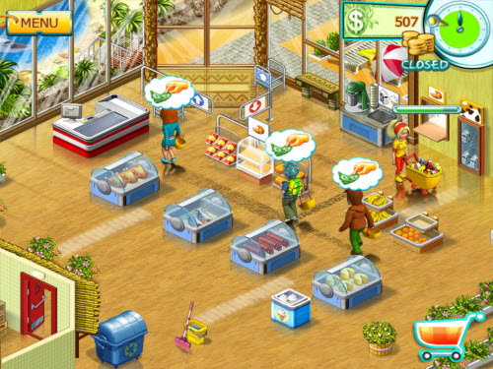

Answer the question about the picture :
- What can you see on the picture?
- Where do you think it is?
- What can you buy in it?
- What can you buy in it?
We make shopping list to buy some thing
For example: in the market / supermarket we can buy:
- Vegetables
- Tomato Chiken
- Broccoli Eggs
- Lobster Mushroom
- Meat Carrots
- Peppers fish
- Fruits
- Banana Papaya Pear
- Apples Oranges Mango
- Avocado Grapes Cherry
- Clothes, sports equipment, house tools, school equipment etc.
- Learning methods
- PPl (the presentation, practice, product)
- Contextual teaching learning approach
- Steps of activities (cycle 1):
1. | A. Pre teaching  - apperception / greeting  - absence and fill journal  - checking students, classes, and the environment | 5 minutes
2. | B. Main teaching  - Student listen and respond to the material introduction Shopping list  - The teacher explains the material Shopping list  - Teachers give example Shopping list to student  - The tachers divides the students into five groups  - Student are able to classify the shopping list on  - students are able to make a shopping list  - students understand the vocabulary of a sopping  - students are able to say “ what are they buy “  - students coclude the material shopping list  -teachers say pronounciation, student repeated it. | 60 minutes
3. | C. Post teaching  - asking the difficulties students  - conclude the material  - pre test vocabulary | 5 minutes

- Learning resources :
- LKS B. Inggris “SMP & TELENTA “ SMP Kls VII, p. 51-56 & 30
Student activity within the PBM
- Book vocabulary test
- English- indonesiandictonary, john M Echol&Hasan Shadily PT Gramedia. Jakarta.
- Scoring
- Written tests
- Student activity within the PBM
Instrument
- Match the places in column A with the column explanation B!
Group A Group B
- Departement store a. sell bread, cakes, pies
- Grocery b. sell Things for writing
- Stationary c. sell clothes and other thing
- Baker d. sell fruit and vegetables
- Fishmonger e. sell fish
- Butcher f. sell flowers
- Greengrocery g. sell meat, chicken, and eggs
- Florist h. sell cars and motor cycles
- Drugstore i. sell medicines and toilet articles
- Dealer h. sell medicines and toilet articles

- Complete the text with the words in the box!
Deluxe supermarket
Deluxe supermarket (1)…………one of big department stores in the city. It is on Abimanyu (2)…………….the building (3)……..of four stores. It (4)………a lot of things.The first floor os for daily needs. The second floor is for mobile phone centre, and the (5)…………..is for clothes. I and my mother usually (6)…………shopping to Deluxe supermarket every Sunday. We go there on foor (7)……………it is not far, about 100 m from my house. We (8)…………some rice, cooking oil,sugar, and other daily needs.
In Deluxe supermarket we have (9)……………and pick the things we want to buy and take them in a basket or (10)…………..to bring to the cashier. We can (11)……………...various goods by ourselves. It is (12)……………to go shopping in a supermarket.
- go - choose - consist - enjoyable
- because - to choose - Sells - Rolley
- buy - Is - other floor - Street

- Give the meaning of these words!
- Shopping : f. Florist:
- Bargain : g. Gardening:
- Sale : h. Land:
- Butcher : i. Houseplant:
- Greengrocer: j. Growing:

- Rubric Assessment
NO | Description | Score
I | Each correct answer  Every wrong answer | 1  0
II | No answer | 0

- Guide assesment
- For the Part I, correct answer score 1
- For the Part II, correct answer score 2
- The number of maximum score 32 x 3 = 96 + 4
Total = 100

Tulungagung 20 Juli, 2014

Teacher English Teacher

Rita Yusdiana, S.pd Agus fahim
NIP. 19720712 200801 2 017 NIM. 3213103035

