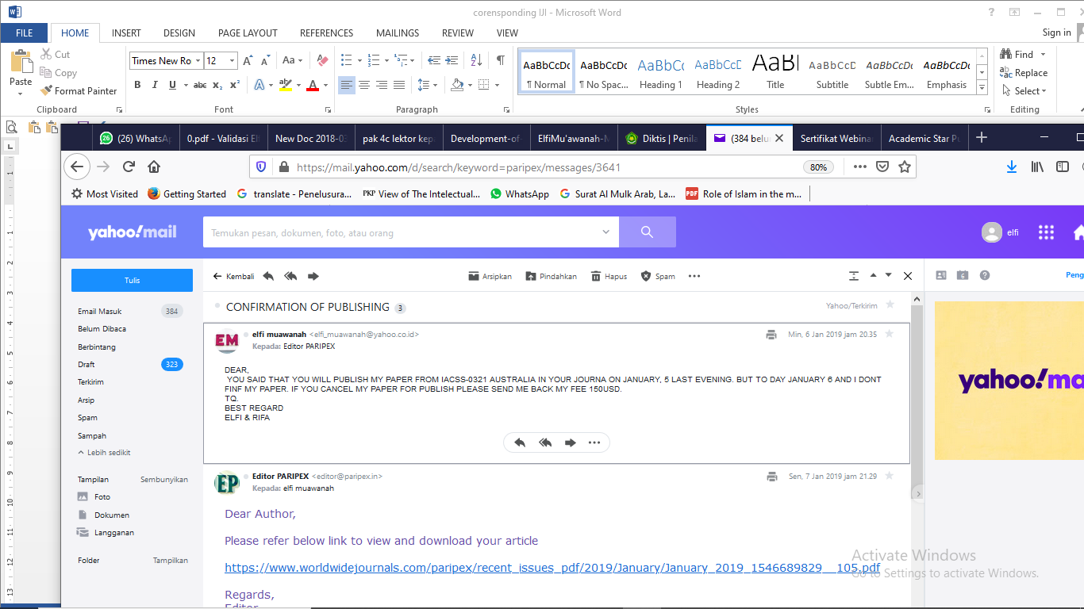
DEAR,
YOU SAID THAT YOU WILL PUBLISH MY PAPER FROM IACSS-0321 AUSTRALIA IN YOUR JOURNA ON JANUARY, 5 LAST EVENING. BUT TO DAY JANUARY 6 AND I DONT FINF MY PAPER. IF YOU CANCEL MY PAPER FOR PUBLISH PLEASE SEND ME BACK MY FEE 150USD.
TQ.
BEST REGARD
ELFI & RIFA

• • • •
•
Editor PARIPEX <editor@paripex.in>
Kepada:elfi muawanah
Sen, 7 Jan 2019 jam 21.29
Dear Author,

Please refer below link to view and download your article

https://www.worldwidejournals.com/paripex/recent_issues_pdf/2019/January/January_2019_1546689829__105.pdf

Regards,
Editor

•

--
The Editor,
PARIPEX - INDIAN JOURNAL RESEARCH
303, Maharana Pratap Complex,
Opp. Kapadia Guest House, B/H V.S.Hospital,
Paldi, Ahmedabad-380006. Gujarat (INDIA)
Cell: +91 8866 00 3636 +91 8866 11 3636
Website: www.worldwidejournals.com
Email Id: editor@paripex.in

•
elfi muawanah <elfi_muawanah@yahoo.co.id>
Kepada:Editor PARIPEX
Sel, 8 Jan 2019 jam 05.23
dear PARIPEX
thank you for publishing our paper. thank you very much
best regard
elfi & rifa

• ,
• • atau
• Kepada:elfi_muawanah@yahoo.co.id
Sen, 25 Mar 2019 jam 16.21

PARIPEX
Indian Journal of Research
Paripex - Indian Journal of Research is an international open access journal providing a platform for advances in basic and advanced clinical medical research for all branches of Medico Professionals. PIJR provides cutting edge updates, developments in the medical arena and helps medical fraternity to syncronize their knowledge in todays time.
Paripex - Indian Journal of Research is publishes paper/research article in every 15th of the month, and hence publishes reviews, articles, short communications and case reports. Authors are encouraged to publish their experimental and theoretical results about molecular and cellular processes in disease, thus to increase understanding of fundamental principles and biological questions of medicines.
Publish Your Article within 3 Working Days
The Journal is inline with MCI norms and index with Index Copernicus Value 86.18
The Journal having an ISSN No: 2250-1991 with Impact Factor of 6.761(SJIF).

Journal Indexing:
The journal is indexed with leading International Indexing agencies like Index Copernicus, Google Scholar, Open J-Gate, IIFS, Citefactor, DJOF, DRJI, Eyesource etc.

How to Submit Article:
If you wish to publish Research Paper/Article kindly follow our | AUTHOR GUIDELINES | And mail to us at | editor@paripex.in | Or you can also directly | UPLOAD YOUR MANUSCRIPT(Artical)| on our web.

Manuscript Submission:
A High Quality research paper are invited those are orignal and plagiarism free must be prepared in MS word with double - column in single spaced typed pages should be submitted electronically as an attachment on E-mail Id of Journals mentioned... editor@paripex.in
Unsubscribe

Don't want to get emails like this? Unsubscribe from our emails
Sent using EngageBay

• • • •
•
elfi muawanah <elfi_muawanah@yahoo.co.id>
Kepada:Editor
Sel, 26 Mar 2019 jam 13.35
dear,
thank for your information. may somes day i will sent you a paper. but if you want i want to be reviewer in your journal. i send you my curriculum vitae for your consideration. thank you very much.

best regard
elfi muawanah

CV elfi muawanah.docx
3.8MB

• ,
• • atau
•

