CHAPTER IV
RESEARCH FINDING

- Overview
- The Background of SDI Walisongo
SDI Walisongo is Islamic education institute on Niyama Street, Tanggul Welahan village, Besuki sub district, Tulungagung regency. SDI Walisongo is found by Muslim Religious of Nahdlatul Ulama (NU) organization and passing by education foundation and social walisongo. In 2005, exactly on March 15th 2005 based on official letter no: 09/P.YP.W/III/2005 that published by Drs. Maryoto Birowo, MM; SDI Walisongo gets operational license SDI Walisongo on Besuki sub distric.
SDI Walisongo is found because the Muslim Religious of Nahdlatul Ulama (NU) organization gives attention to has Islamic education institute. The Muslim Religious have goals of that organization.
The goals of SDI Walisongo are as follows:
- The educators are included in process of developing the intellectual life of the children nation.
- To extend the children talent and potential.
- To increase society education level.
- To create children who have good faith and good characters.
Firstly, SDI Walisongo is leaded by Nur Jaenuri, S.Ag as a headmaster in academic year 2005-2006 until 2010-2011. Then as the end on June 2010, position of head master is changing by Dra. Umi Hanik is as a new Headmaster in academic year 2011-2012.
- The Location of SDI Walisongo
The location of SDI Walisongo on Niyama Street, Tanggul Welahan village, Besuki sub district, Tulungagung regency. That school can be reached by motorcycle or bicycle. The location of school is about 200 meter from highway. It gives advantages for the teachers and students to study seriously and focuses on teaching learning process.
- Vision and Mission of SDI Walisongo
- Vision
- To create the school become progress, has high quality in academic and perspective on SAINS and IMTAQ.
- Mission
- To create the learning system becomes active, conducive, creative, affective and fun situation.
- To create the school condition becomes comfort and harmonious condition.
- To extend the student talent, interest and creativity.
- To disappear some obstacles that hampered in order to reach teaching learning interaction.
- To foster the students behavior, attitude and morals in the students life.

- The Structure Organization of SDI Walisongo
Kepala Sekolah

Unit perpustakaan
Unit kesehatan sekolah (UKS)
Bendahara
Jabatan guru
Guru mata pelajaran
Siswa

Masyarakat
Masyarakat
Masyarakat

Ketua Komite Sekolah

- The Teacher and Worker of SDI Walisongo
The teachers are an important aspect on education. The teachers have responsibility to acquire the student’s competence and to educate on teaching learning process. The teachers are believed by parents and member of society to educate the student’s spiritual development. So, the teachers must have high commitment and loyalty toward their profession and has responsibility on teaching learning process at school.
The number of teacher and worker of SDI Walisongo are 15 members; consist of 13 teachers and 2 workers. The number of English teacher is two teachers. For clearly, the teachers and the worker names can be seen on this table:
Table 4.1
The Teachers and Worker of SDI Walisongo
No | Name | Profession | Subject
1 | N J R | Head master | -
2 | S T W | Teacher | Teacher of class I
3 | S PN | Teacher | Teacher of religion
4 | A N F | Teacher | Teacher of class V
5 | R C M | Teacher | Plastics art
6 | I M M | Teacher | Teacher of class III
7 | E W C | Teacher | Computer
8 | S R W | Teacher | Teacher of class IV
9 | S B H | Teacher | Teacher of class II
10 | S P T | Teacher | Teacher of sport
11 | A M D | Teacher | Teacher of class VI
12 | H T N | Teacher | English
13 | P W I | Teacher | Computer
14 | A I K | Worker | TU
15 | N R L | Worker | TU

- The Students Condition of SDI Walisongo
The students are the main subject on education. The students have right and responsibility on teaching learning process at school. The students have right to get good teaching, knowledge, comfort situation and professional teachers. The student’s responsibilities are to obey the school rules and join on teaching learning process. The student number of SDI Walisongo is changing for every year. The number of the students in academic year 2010-2011 is 115 students. The student’s condition of fifth class can be seen on appendix 1. To know the students condition for every class can be seen on this table:
Table 4.2
The students condition of SDI Walisongo
No | Class | Amount of student
 |  | Male | Female | Amount
1 | I | 12 | 7 | 19
2 | II | 6 | 6 | 12
3 | III | 7 | 5 | 12
4 | IV | 8 | 15 | 23
5 | V | 12 | 11 | 23
6 | VI | 16 | 10 | 26
 | Total | 61 | 54 | 115

- The Equipment On Teaching English
Organization of education can be released from school equipment. Completely equipment can be supported the teachers and the students on teaching learning process. By using good equipment, the teachers can transfer knowledge and materials to their students easily and the students can to receive knowledge and message from teacher’s explanation easily. The equipment used as follows: blackboard, table and chair for the teacher and the students and also educated pictures.

- Data Presentation
- The Teacher’s Strategies to Motivate the Students
Motivation is something important in our live. Motivation gives more energy to reach something in daily life. For the students, motivation is important factor to contribution in order to support or stimulate students on success or failure on learning process. The teacher as an extrinsic motivation has big factor to create success on teaching learning process. The teacher’s motivation is important factor to motivate the students to be active, become more enthusiasm and to get good achievement on learning activity especial for English lesson.
Based on observation on May 14th 2011, on May 21th 2011 and on May 28th 2011 at SDI Walisongo, the teacher’s strategies to motivate the students on changing the student’s learning English attitude are as follows:
- The teacher goes around in the classroom to look at the students work. If the students do not understand about the material the teacher gives explanation again.
- The teacher makes different method in every teaching process. The purpose is to avoid students boring. The method is used by the teacher as follows: make small group, teacher’s explanation and peer in work. Small group is used by the teacher to make students become active on learning English. Explanation is used by the teacher to transfer knowledge and give explanation about new material that the students not understand before. After giving the explanation, the teacher gives opportunity for the students to ask about material. Peer in work is used to give opportunity to the students to ask toward their friends and make students closed with others.
- The English teacher gives home work, task (LKS) and exam.
- To create students active and enthusiasm on learning English, the teacher gives some ways, as follows:
- The teacher gives score
The teacher gives score for student’s activities in the classroom. Those activities can be forming exam or evaluation the students cognitive, affective and psychometric on learning process. The teacher gives score for the students who are active during teaching learning English. Giving score makes the students active to learn English lesson.
- The teacher gives punishment
The teacher will give punishment to the students who made mistake in the classroom. The mistakes that usually done by the students as likes: the students don’t give attention during teaching process, the students crowded in the classroom during teaching learning process and the students do not do their task and home work. The punishment that given by the teachers as follows: first time the teachers just give warning and suggestion to the students, and if the students make mistake again the teacher will give punishment as like asking the students to stand up in front of class. The teacher gives punishment to remind the student’s mistake so they never repeat again those mistakes.
- The teacher gives praise
The teacher will give praise to the students who are able to finish or unsuccessful on the task. The praise can be concrete with a comment to the students using some word such compliment: good job, very good, thank for your answer, excellent, thank you and try again. Those words make the students feel respect toward their effort.
- The teacher gives exam
The English teacher gives exam every finishing two chapters or it is determined with the material. The exam is given to acquire student’s ability and understanding toward the material. The kinds of exam are like essay, arrange sentences and matching. The teacher never use multiple choice because to avoid the students cheating and chatting during the test.
- The teacher always gives advice to the students to study hard at home for every last meeting.
The problem is faced by the English teacher to motivate students on increasing the student’s learning English attitude as follows: some students are not interesting toward English lesson (their reason is English lesson is difficult to learn), some students make disturbance or they disturb other students during teaching learning process in the classroom.
- Teaching and Learning Process in the Classroom
From the result of interview with the English teacher on May 21th 2011 and observation on fifth class, the researcher gets some point about teaching learning process in the classroom. Generally, the teaching process begins at 07.00 until 12.30 p.m. especially for the English lesson is teaching for every Tuesday on the third and the fourth period. The meeting begins at 08.30 until 10.00 pm. The teacher gives different material and method on teaching process for every meeting. It is done to avoid the students boring to study English. The students feel English lesson is difficult to learn, because English has different spelling and writing and also as a new language for the students lives.
The teaching learning English at SDI Walisongo on the fifth year class as follows:
- On teaching vocabulary: the English teacher gives simple until difficult vocabulary, so it adds the students’ new vocabulary and they can remember new vocabulary.
- On making and replaying letter: the teacher makes mall group consist of 2-4 students. It makes the students more interest to study English and feel happy to work together with their friends. The teacher uses this method because it is very effective to make the students become active and increase the student’s participation on making and replaying letters.
- On doing task (LKS): after the teacher’s explanation about the material, the teacher asks the students to work the task by their selves. It’s done by the teacher to acquire the students understanding about the teacher’s explanation.
- On giving examination: the teacher gives exam after finishing the material. The exam is after finishing 2 chapters or it is determined by the material. The kinds of question can be form arrange sentences, easy and matching. The English teacher seldom uses multiple choices to avoid the students cheating and chatting. The score standard (KKM) of English lesson is 70. If the students can’t reach those score, the teacher gives opportunity to the students to do again or get new questions to repair their score.
- The Student’s Attitude of the Fifth Class
The result of observation on May 14th 2011, the researcher gets some points of the student’s attitude in the classroom. The student’s attitude as follows:
- The female students give more attention toward learning English rather than male students.
- Some students like to draw and make noisy during teaching learning English.
- The students make small group on doing task or LKS.
- The students ask the English teacher if they get problem.
The result of observation on May 21th 2011, the students show their changing attitude on teaching learning English in the classroom. The student’s changes are as follows:
- The male students begin to give response and attention toward English lesson, because the teacher gives them warning toward their mistake in the classroom.
- The teaching learning process run well and the students feel happy with the material.
The last observation is considered on May 28th 2011, all of the students give pay attention toward the teacher’s explanation during teaching learning process. The teaching processes runs well.
- Result of Interview With the English Teacher
The researcher holds interview with the English teacher at SDI Walisongo on May 23th 2011. The interview is conducted to know the English teacher’s strategies to motivate the students on teaching learning process, to know the teaching learning English in the classroom, to know the student’s learning English attitude of the fifth class.
The respondent (English teacher) explains that the strategies to motivate the students on learning English are: the teacher gives homework, task (LKS), exam, the teacher uses different method on teaching, the teacher goes around to control the students work in the classroom.
The teacher and the students activities in the classroom are: the teacher takes the material from Basic English Book, the teacher chooses the material and explains one by one of those topic. After that, the teacher gives opportunity to the students to ask if they do not understand the material. On giving explanation the English teacher uses Indonesia language. The teacher gives evaluation after finishing one or two chapter or appropriate with the material. The kind’s questions of exam are: matching sentences essay and arrange sentences. The teacher gets score from the aspects of achievement (cognitive, affective and psychometric) and result of exam.
The respondent (English teacher) explains that the student’s attitude of the fifth class is different. Some students make a noise, disturb and draw during teaching learning English and the student’s interest work together with their friends. To avoid the students noisy and draw picture in teaching process, the English teacher gives them warning and punishment. The kind of punishment can be form by giving warning, suggestion, to stand up in front of class and out of class.
The influence of the teacher’s motivation is: the students seen more enthusiasm on learning English, the students become active on answering the teacher question and the students can be reach score above of KKM (70). It means that, the teacher’s motivation strategies as an extrinsic motivation is important aspect to increase the student’s attitude on learning English.
- The Result of The Documentation
  - The English teacher explanation
Picture 4.3
The English teacher explanation

The English teacher explains about “how to make letter”. This section, the teacher gives explanation about vocabulary, example of letter and how to reply simple letter. On giving explanation the English teacher uses Indonesia language (to make easy on transferring knowledge) and English language sometime in used. All of the students on fifth class give attention toward the English teacher explanation.

  - The English teacher around in the classroom
Picture 4.4
The English teacher around in the classroom
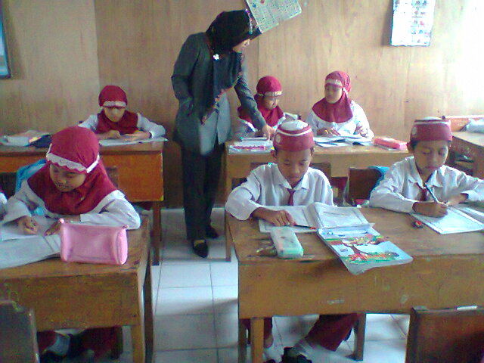

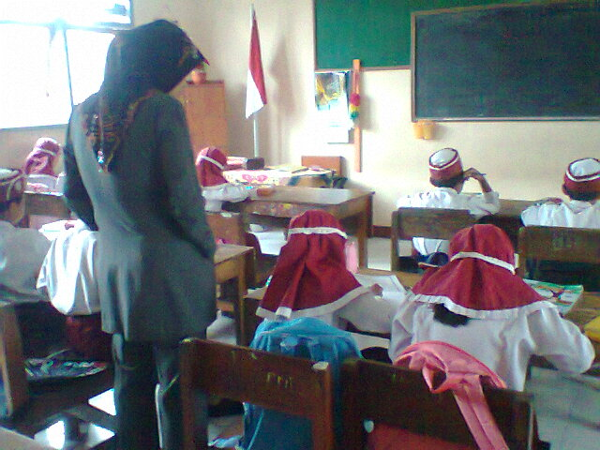

The goal of the English teacher around in the classroom is to check the student’s activities on doing LKS, to motivate the students more serious on doing the task and to make relation closer with the students.

  - The students activities doing the LKS
Picture 4.5
The student’s activities in the classroom

The students do the LKS to measure their understanding about the material that the English teacher explains before. The students do the exercise seriously and they do the task by their selves.
  - The students attitude on learning English
Picture 4.6
The student’s attitude on learning English

The student’s feel enthusiasm and active on teaching and learning process. They are interesting to learn English lesson.
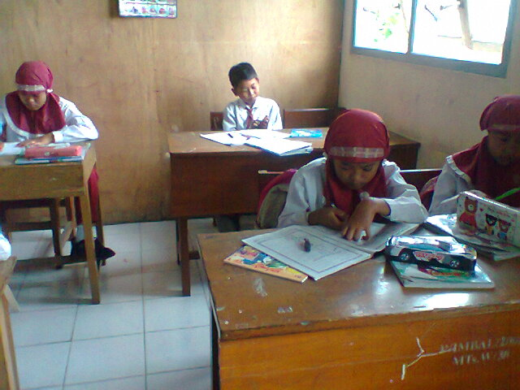

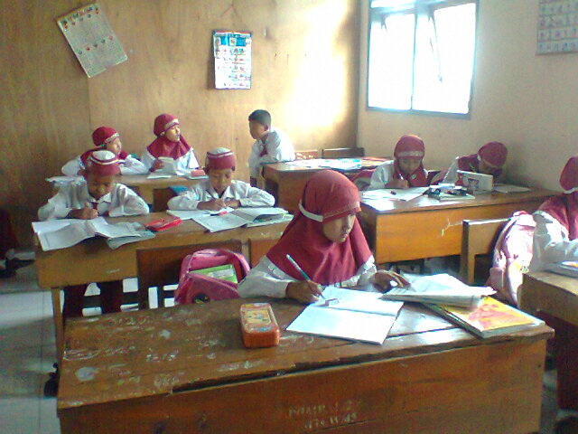

From the picture above can be seen that the entire student’s active and serious doing the exercises that given by the teacher. But some of the students like to draw picture and play during teaching and learning process. He does not do the task that given by the teacher. He interest to play and disturb other students. He disturbs to see other students work.

