APPENDIX 1
Procedure of Make a Match Method
- Teachers set up some cards that contain some concept of session, otherwise the part about the card and the card other answer.
- Each student receives a one-card hand.
- Each student think of an answer or a question of card held.
- Each students seeking a partner who has a card that matches the card (about the answer)
- Any the student who can match his card before the deadline given points.
- After one round of cards, shuffled again so that each students gets a different card than before.
- So forth
- Conclusion or closing

APPENDIX II

Make a Match Method as Experimental

Match the sentences with the correct answer in the box.
- Mrs. Rita work in the library. She is a………………….
- If we want to have our hair cur. We go to a…………..
- Anton sells many kinds of food in the market. He is a…………..
- My father repairs cars. He is a……………………
- Mr. johan work in the garden. He is a………………….
- Someone who plants rice in the field is a…………………..
- Mr. Dadang regulates the traffic. He is a……………………
- Mrs. Nurma makes clothes. She is a………………………….
- Andri has a toothache. His mother takes him to the……………….
- Someone who makes delicious food is a……………………….
- gardener f. merchant
- Policeman g. farmer
- Dentist h. tailor
- Librarian i. chef
- Barber j. mechanic

i. chefrber j. mechanic

APPENDIX III
Test for Experimental Pre-test
Choose the correct answer by crossing a, b, c or d
- The ………. Deliver the mail and package everyday.
- Blacksmith b. fisherman c. postman d. reporter
- Who plants rice in the field is a…………….
- Farmer b. bricklayer c. sailor d. plumber
- The …………….. catches fish in the sea.
- Farmer b. carpenter c. fisherman d. blacksmith
- My uncle can help switch off the fair, he is a……………..
- Fireman b. policeman c. painter d. sailor
- Mr.fajar is a teacher, he is work in………………
- office b. hospital c. station television d. school
- Mr. angga work in police station. He is a…………………
  - Blacksmith b. policeman c. painter d. merchant
- My mother work in hospital, she is a………………………
  - Doctor b. teacher c. farmer d. driver
- The ……………… treats the patient who suffers from toothache.
  - Doctor b. dentist c. nurse d. teacher
- My father work in rice field, he is a………………….
  - Farmer b. carpenter c. fisherman d. blacksmith
- Someone who work in plane is a………………….
  - Driver b. soldier c. sailor d. pilot

- Mention ten kinds of profession
- …………………………
- …………………………
- …………………………
- …………………………
- …………………………
- …………………………
- …………………………
- …………………………
- …………………………
- …………........................

APPENDIX IV
Key Answer for Experimental Pre-test

- 1. C
2. A
3. C
4. A
5. D
6. B
7. A
8. B
9. A
10. D
11. 1. Teacher
2. doctor
3. farmer
4. fisherman
5. dentist
6. merchant
7. sailor
8. tailor
9. soldier
10. reporter

APPENDIX V
Test for Experimental Post-test

- Choose the correct answer by crossing (x) a, b, c or d
Dialogue for number 6 to 8
Rio :” what do you want to be someday?”
Lisa : “I want to be a chef someday.”
Rio : “where is your father work?”
Lisa : “my father work in post office.
Rio : “ where is your sister work?”
Lisa : “my sister work in restaurant.”

- Lisa want to be a………………
- Doctor b. chef c. typist d. waiter
- Lisa father work in post office, he is a…………..
- Waiter b. merchant c. carpenter d. postman
- Lisa sister work in restaurant. She is………………
- Waiter b. singer c. dancer d. reporter
- Andy : “where is your sister work?”
Brian : she is work in shop .”
Andy : “what is your sister?”
Brian : “she is a…………….”
- Nurse b. dentist c. doctor d. shopkeeper

Reading for number 5-7
Hello, friends! Let me introduce my self. My name is Nanang. I am a students. I am the students of the fifth class. I will tell you something about Mr. Udin. He is work in the school library. His wife work in the hospital.
- What is Nanang……………..
- Students b. teacher c. librarian d. waiter
- Mr. udin work in library, he is a………………
- Farmer b. librarian c. gardener d. fisherman

- Mr. Udin wife work in hospital, she is a………………
- Waiter b. reporter c. nurse d. teacher
- Anwar : what is your brother?
Indra : he is ………….
Anwar : where does he work?
Indra : he work in station television.
What is Anwar brother………..
- Reporter b. barber c. tailor d. waiter
Dialogue for number 9-10
Intan : hello Candra! how are you?
Candra : hello Intan, I am fine and you?
Intan : Iam fine too, where you work?
Candra : I work in hospital. And how about you?
Intan : I work in supermarket.
- What is Candra………….
- Mechanic b. carpenter c. secretary d. dentist
- Intan work in supermarket, she is a…………..
- Cashier b. tailor c. barber d. waiter

- Mention 5 profession in the hospital and 5 profession in the station television.

Five profession in the hospital | Five profession in the station television
- …………………… | 1. …………………..
- …………………… | 2. ……………………
- …………………… | 3. ……………………
- …………………… | 4.……………………
- …………………… | 5.……………………

APPENDIX VI
Key Answer for Experimental Post-test

- 1. B
2. D
3. A
4. D
5. A
6. B
7. C
8. A
9. D
10. A

Five profession in hospital | Five profession in station television
Doctor | Singer
Dentist | Dancer
Nurse | Comedian
Obstetrician | Reporter
ophthalmologist | Actor

APPENDIX VIII
Table Distribution t Students
d.b | significance
 | 5%(0.05) 2%(0.02) 1%(0.01)
1 | 12.706 | 31.821 | 63.657
2 | 4.303 | 6.965 | 9.925
3 | 3.182 | 4.451 | 5.841
4 | 2.776 | 3.747 | 4.604
5 | 2.571 | 3.365 | 4.032
6 | 2.447 | 3.143 | 3.707
7 | 2.365 | 2.998 | 3.499
8 | 2.306 | 2.896 | 3.355
9 | 2.262 | 2.821 | 3.250
10 | 2.228 | 2.764 | 3.169
11 | 2.201 | 2.718 | 3.106
12 | 2.179 | 2.681 | 3.055
13 | 2.160 | 2.650 | 3.012
14 | 2.145 | 2.624 | 2.977
15 | 2.131 | 2.602 | 2.947
16 | 2.120 | 2.583 | 2.921
17 | 2.110 | 2.567 | 2.898
18 | 2.101 | 2.552 | 2.878
19 | 2.093 | 2.539 | 2.861
20 | 2.086 | 2.528 | 2.845
21 | 2.080 | 2.518 | 2.831
22 | 2.074 | 2.508 | 2.819
23 | 2.069 | 2.500 | 2.807
24 | 2.064 | 2.492 | 2.797
25 | 2.060 | 2.485 | 2.787
26 | 2.056 | 2.479 | 2.779
27 | 2.052 | 2.473 | 2.771
28 | 2.048 | 2.467 | 2.763
29 | 2.045 | 2.462 | 2.756
30 | 2.042 | 2.457 | 2.750
40 | 2.021 | 2.423 | 2.704
60 | 2.000 | 2.390 | 2.660
120 | 1.980 | 2.358 | 2.617
APPENDIX IX

CERTIFICATE OF AUTHORSHIP

The undersigned below,
Name : Sulistiani
Place, date of birth : Trenggalek, 17 march 1989
Registered Number : 3213083125
Address : Panggul, Trenggalek
Department : STAIN Tulungagung
Program : English Education Program

Certify that the thesis which I wrote to fulfill the requirement for Islamic education degree entitled “ The Effectiveness of Using Make a Match Method to the Vocabulary Achievement for the Fifth Grade the Students of SDN II Plosokandang” is truly my original work. It doesn’t incorporate any materials previously written or published by another person exped those indicated in guotation and bibhography. Due to the fact, I’m only person responsible for the thesis if there is any an objection or claims for other.

Tulungagung, juli….2012
Who make the statement

Sulistiani
Nim:3213083125

APPENDIX X

Curriculum Vitae

Name : Sulistiani
Place and date of birth : Trenggalek, 17 march, 1989
Religion : Islam
Address : Karangtengah, Panggul, Trenggalek

Bacground of study:

Graduate from SDN 04 karangtengah (2001)
Graduate from SMPN 02 Panggul (2004)
Graduate from MAN Panggul (2008)
Graduate from STAIN Tulungagung (2012)

APPEND XI
LIST OF THE STUDENTS FIFTH GRADE SDN II PLOSOKANDANG

NO | NAMA | GENDER
1 | AHMAD MUKTI | MALE
2 | AFITA SOFIA BUDI | FEMALE
3 | CICI NUR INDAH SARI | FEMALE
4 | CRISTINE KUSUMA NINGSIH | FEMALE
5 | DINDA ROSADAH | FEMALE
6 | DHENI SETIAWAN | MALE
7 | EVA NORMA JUWITA | FEMALE
8 | FAISAL ALI MUKSIN | MALE
9 | MUHAMAD IQBAL SURURI | MALE
10 | MUHAMAD FATHUL MUKLIS | MALE
11 | MURSYIDAH LATIFATUL K | FEMALE
12 | MUHAMAD ANTIQ ATTA M | MALE
13 | MAUIDHATUL MAZARINA | FEMALE
14 | MUHAMAD RISKY SAPUTRA | MALE
15 | NEIHA DANI FITRI | FEMALE
16 | PONI HENDRI HERMAWAN | MALE
17 | RISKY NUR FADILA | FEMALE
18 | RAFIKA RESTI MAWI M | FEMALE
19 | SULISTIAWAN DANI ABDI N | MALE
20 | SAMSUL ARIFIN | MALE
21 | TRISNA MULANDARI | FEMALE
22 | WARDHATUL UMAH | FEMALE
23 | WAHYU ESA PUTRA | MALE
24 | WENI AYU LESTARI | FEMALE
25 | SAKA PAWA | MALE

APPENDIX XII
When the Students Doing Pre-test

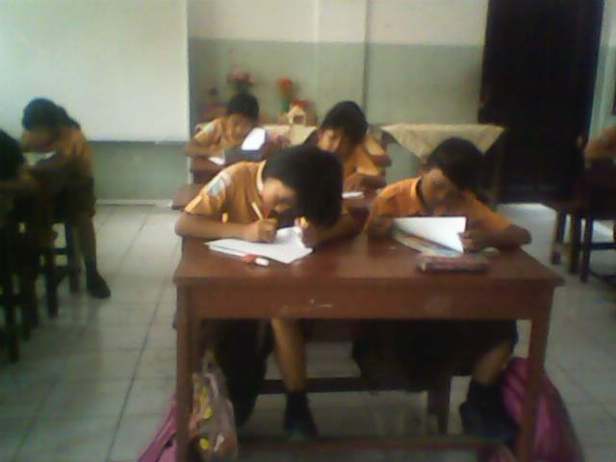

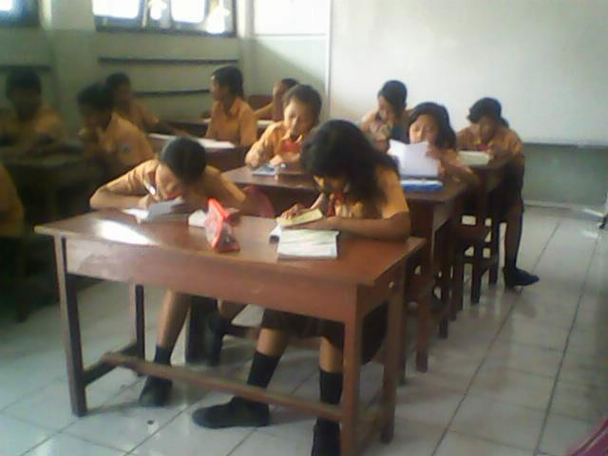

APPENDIX XIII
When Teaching by Make a Match Method

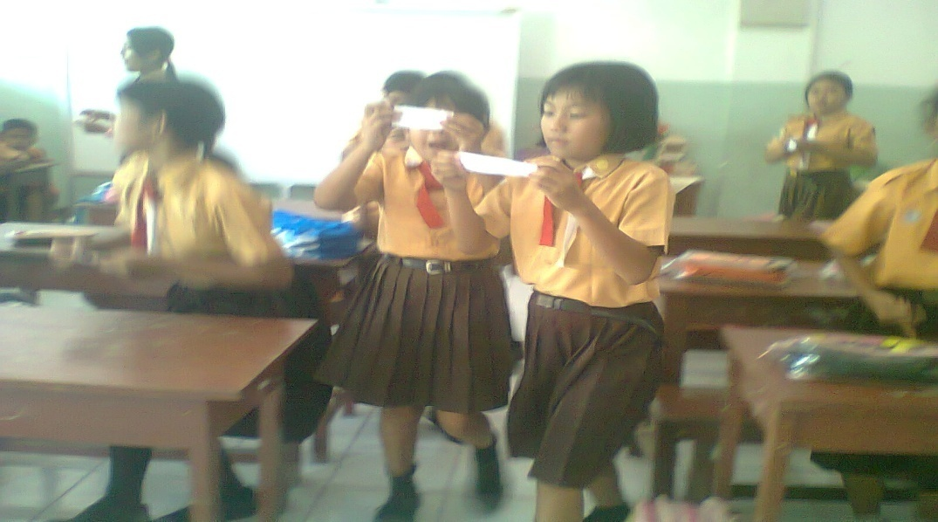

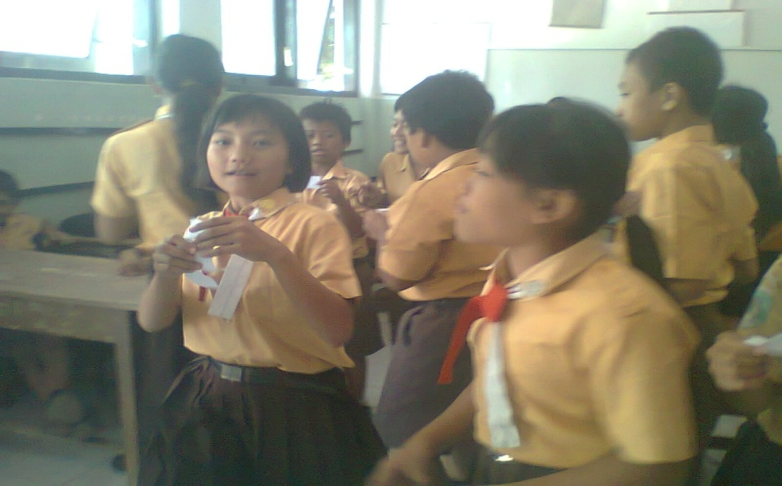

APPENDIX XIV
When the Students Doing Post-test

