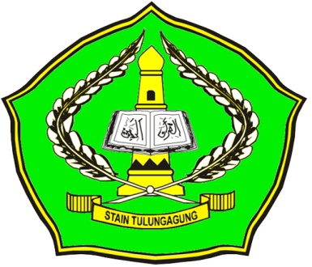

A STUDY ON ABILITY AND PROBLEMS IN WRITING NARRATIVE ESSAY OF THE SECOND SEMESTER STUDENTS OF ENGLISH DEPARTMENT STAIN TULUNGAGUNG

THESIS:
Presented to
State Islamic College of Tulungagung in partial fulfillment of the requirements for the degree of Sarjana Pendidikan Islam in English Education Program

By:
EVERISIAN HIDAYATI
NIM. 3213083006

ENGLISH EDUCATION PROGRAM
DEPARTMENT OF ISLAMIC EDUCATION
STATE COLLEGE FOR ISLAMIC STUDIES
(STAIN) TULUNGAGUNG
July 2012

