APPENDIC 1.
Test of Pre test
Name :
Class :
Time : 35 Minutes
Test : English Vocabularies
Date :
Choose the correct answer by crossing a, b, c, d !

- It is my ....
- Eyes c. Foot
- Head d. Nose
2. We walk with our ....
a. Hand c. Knee
b. Foot d. Finger
3. I have two ....
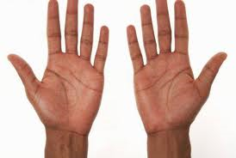
- Hands c. Foot
- Nose d. Arm
4. We listening to music with our ....
a. Nose c. Eyes
b. Lips d. Ears
5. We smell something with our ....
a. Nose c. Foot
b. Hand d. Lips

6. It is an ....
- Orange c. Apple
- Guava d. Grape
7. The students get ceremony on ....
a. Sunday c. Tuesday
b. Monday d. Wednesday
8. The students get holiday on ....
a. Sunday c. Tuesday
b. Monday d. Wednesday
9. The day after Tuesday is ....
a. Sunday c. Friday
b. Wednesday d. Saturday
10. The day after Friday is ....
a. Sunday c. Wednesday
b. Saturday d. Thursday
11. June, August, September are the name of ....
a. Months c. Fruits
b. Days d. Animal
12. Apple, banana, grape are names of ....
a. Days c. Food
b. Fruits d. Beverages
13. A .... has very long neck.
a. Giraffe c. Elephant
b. Cat d. Snack
14. Andui goes to the zoo, he sees an animal from australia, it is ....
a. Lion c. Tiger
b. Kangoroo d. Bear
15. It is a ....
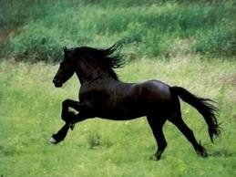
- Lion c. Horse
- Snack d. Cow
16. Ari : “What animal is it ?”
Rio : “It is an ....”
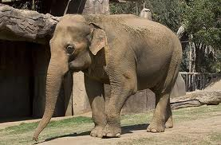
- Elephant c. Buffalo
- Ant d. Crocodile
17. I have one ...
- Nose c. Eyes
- Mouth d. Forehead
18. Ina : “Do you like .....?”
Ani : “Yes, I do”
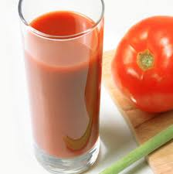
- Orange Juice c. Avocado Juice
- Tomato Juice d. Mango Juice
19. Robi : “How many apples are there ?”
Rio : "There are .... apples"
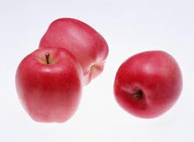
- Three c. Four
- Two d. Five
20. The green one is colour of ....
- Banana c. Apple
- Plate d. Pineaple
21. It is .... season
- Rainy c. Sunny

- Windy d. Cloudy

22. A : “ Do you have a cat ?”
B : “ No, I do not”
A : “ What do you have ?”
B : “ I have a ....”
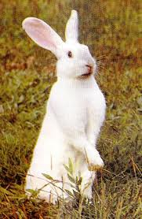
- Robot c. Rabbit

- Rebbit d. Cat

23. Arrange the letter to make the name of day !
H - t - u - r - d -y -s – a
- Tuesday c. Saturday

- Holiday d. Thursday

24. How many fingers do you have ?
- Tent c. Ten

- Eight d. Two

25. Between forehead and eyes we have ....

- Eyeliner c. Eyes

- Eyebrow d. Eye Shadow

APPENDIC 2.
Test of Post-test

Name :
Class :
Time : 35 Minutes
Test : English Vocabularies
Date :

Choose the correct answer by crossing a, b, c, d !

- It is a ....
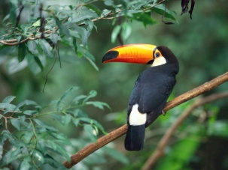
- Bird c. Mouse
- Cow d. Camel

- I see .... in the aquarium.
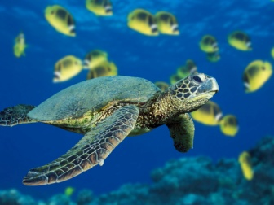
- Snack c. Snail
- Dog d. Turtle

- A .... have long trunk.
- Elephant c. Camel
- Giraffe d. Horse

- It is a ....

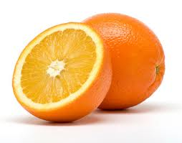
- Tomato c. Orange
- Water Melon d. Papaya

- What is the colour of the fruit below ?
- Red c. Green
- Yellow d. Purple

- It is a ....
- Cat c. Crocodile
- Mouse d. Snail

- Ria : “Do you like .... ?”
Tia : “Yes, I do.”
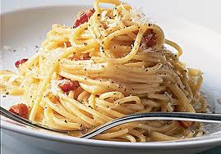
- Fried Rice c. Noodle
- Porridge d. Meat Ball

- There are .... months in a year.
- Eleven c. Thirteen
- Twelve d. Teen

- The first month is ....
- March c. January
- February d. April

- The month after August is ....
- June c. April
- July d. September

- It is a glass of ....
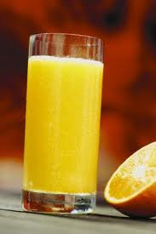
- Milk c. Tomato Juice
- Mineral Water d. Orange juice

- It is Strawbery. The colour is ....
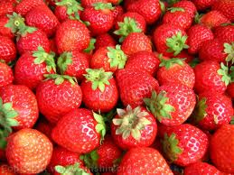
- Yellow c. Brown
- Grape d. Red
- It is my ....
- Lips c. Cheek
- Ears d. Nose

- It is a ...
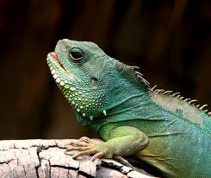
- Snack c. Goat
- Frog d. Komodo
- There are five .... on each hand.
- Fingers c. Ring fingers
- Tumb d. Foot
- Linda’s .... is black, long, and curly.
- Hair c. Head
- Hand d. Finger
- We wear hat and helmet on our ....
- Hand c. Chin
- Foot d. Head

- It is my ....
- Hand c. Foot
- Tooth d. Face

- What picture is it?
- Ice Cream c. Chocolate
- Ice Tea d. Coffe

- I like ...
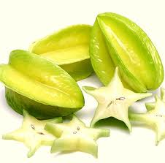
- Jack Fruit c. Mango
- Star Fruit d. Guava

- A : “ Do you like .... ?”
B : “ Yes, I do”
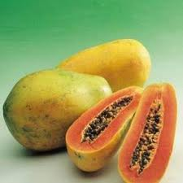
- Pepaya c. Jack Fruit
- Apple pie d. Papaya

- What picture are they ?

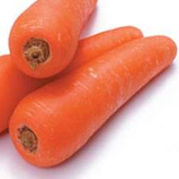
  - Orange c. Parrot
  - Carrot d. Vegetables

- Arrange the letter into the name of fruit
M – l – w – a – e – r – o – n – t – e
  - Water Melon c. Melon Tawer
  - Melon Water d. Tawer Melon
- These are .... and .... season.
  - Happy and Cry c. Dry and Rainy
  - Sun and Water d. Two Frogs

- Today is Saturday, tomorow is ...
  - Saturday c. Sunday
  - Friday d. Monday

APPENDIC 3.
Try Out Part 1
The Mean Score Calculation of Try Out Part I
X | f | Fx
40 | 1 | 40
36 | 1 | 36
32 | 1 | 32
28 | 1 | 28
24 | 1 | 24
20 | 6 | 120
16 | 4 | 64
12 | 5 | 60
TOTAL ( $∑fx$) |  | 404

m = $\frac{∑fx }{N}$
Where,
N : the number of the testees
$∑fx$ : the sum of (fx)
m = $\frac{ 404}{20}$
= 20.2
= 20

The Standard Deviation Calculation of Try Out Part I
Score | Mean Deviation (d) | Squared (d²)
40 | 20 | 400
36 | 16 | 256
32 | 12 | 144
28 | 8 | 64
24 | 4 | 16
20 | 0 | 0
20 | 0 | 0
20 | 0 | 0
20 | 0 | 0
20 | 0 | 0
20 | 0 | 0
16 | -4 | 16
16 | -4 | 16
16 | -4 | 16
16 | -4 | 16
12 | -8 | 64
12 | -8 | 64
12 | -8 | 64
12 | -8 | 64
12 | -8 | 64
TOTAL |  | $∑d^{2}=$1264

Note:
- Find out the amount by which each score deviates from the mean (d);
- Squared each result (d²)
s.d = $\sqrt{\frac{∑d²}{N}}$
Where
$∑d²$ : total all the result;
N : the number of testees;
s.d : standard deviation.
s.d = $\sqrt{\frac{1264}{20}}$
= $\sqrt{63.2}$
= 7.95

APPENDIC 4.
Try Out Part 2
The Mean Score Calculation of Try Out Part II
X | f | Fx
56 | 3 | 24
52 | 8 | 96
44 | 4 | 64
40 | 1 | 20
36 | 1 | 24
32 | 1 | 28
28 | 1 | 32
24 | 1 | 52
TOTAL ( $∑fx$) |  | 340

m = $\frac{∑fx }{N}$
= $\frac{340}{20}$
= 17
The Standard Deviation Calculation of Try Out Part II
Score | Mean Deviation (d) | Squared (d²)
52 | 35 | 1225
32 | 15 | 225
28 | 11 | 121
24 | 7 | 49
20 | 3 | 9
16 | -1 | 1
16 | -1 | 1
16 | -1 | 1
16 | -1 | 1
12 | -5 | 25
12 | -5 | 25
12 | -5 | 25
12 | -5 | 25
12 | -5 | 25
12 | -5 | 25
12 | -5 | 25
12 | -5 | 25
8 | -9 | 81
8 | -9 | 81
8 | -9 | 81
TOTAL |  | 2076
s.d = $\sqrt{\frac{2076}{20}}$
= $\sqrt{103.8}$
= 10.2

APPENDIC 5.
The Students’ Score of Pretest
No. | Initial Name | Score
1. | A | 64
2. | B | 80
3. | C | 64
4. | D | 52
5. | E | 72
6. | F | 76
7. | G | 68
8. | H | 52
9. | I | 80
10. | J | 44
11. | K | 52
12. | L | 80
13. | M | 84
14. | N | 68
15. | O | 60
16. | P | 68
17. | Q | 60
18. | R | 84
19. | S | 84
20. | T | 76
 |  | $\sum{x}$ = 1368

APPENDIC 6.
The Students’ Score of Post-test
No. | Initial Name | Score
1. | A | 84
2. | B | 88
3. | C | 80
4. | D | 72
5. | E | 76
6. | F | 88
7. | G | 76
8. | H | 76
9. | I | 88
10. | J | 60
11. | K | 72
12. | L | 92
13. | M | 96
14. | N | 88
15. | O | 76
16. | P | 80
17. | Q | 76
18. | R | 96
19. | S | 88
20. | T | 88
 |  | $\sum{y}$ = 1640

APPENDIC 7.
CURRICULUM VITAE

Name : Fuadi Muhammad
Sex : Male
Place, date of birth : Trenggalek, December 12nd, 1991
Registered number : 3213083060
Address : Tugu – Nglongsor – Trenggalek
Department : Departement of Islamic Education in State Islamic College
(STAIN) of Tulungagung
Program : English Education Program
Background of the Study :
- Graduated from Elementary School in 2001.
- Graduated from Junior High School in 2004.
- Graduated from Senior High School in 2007.
- STAIN Tulungagung.

APPENDIC 8
The Key Answers of Pre-test and Post-test
- Key Answers of Pre-test
- A 16. A
- B 17. A
- A 18. B
- D 19. A
- A 20. C
- C 21. C
- B 22. C
- A 23. D
- B 24. C
- B 25. B
- A
- B
- A
- B
- C

- Key Answers of Post-test
- A 16. A
- D 17. D
- A 18. C
- C 19. A
- B 20. B
- B 21. D
- C 22. B
- B 23. A
- C 24. C
- D 25. C
- D
- D
- A
- D
- A

